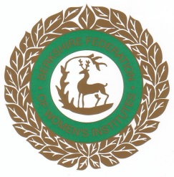
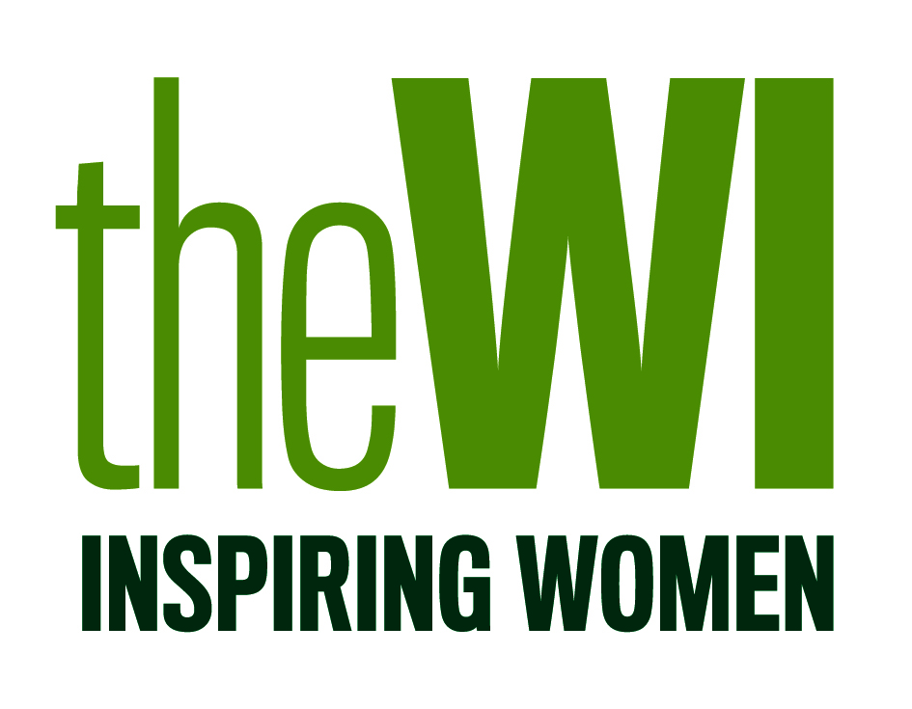

Dear Member,

A very warm welcome to the WI. You are now part of the largest women’s organisation in England and Wales with more than 190,000 members in over 6,000 WIs. Berkshire Federation has approx. 2,500 members in 61 WIs. The WI was formed in 1915 to revitalise rural communities and encourage women to become more involved in producing food during the First World War. Ever since its aims have expanded with the WI playing a unique role in providing women with educational opportunities, to learn new skills and take part in a wide variety of activities.

Your membership entitles you to 11 regular WI meetings and 8 copies of WI Life per year. The WI membership booklet, which will be sent to you each year, contains lots of special offers and vouchers. You will also have access the WI Learning Hub and the Digital WI - MyWI - full of news, information and projects.

Berkshire Federation has its own newsletter - Berkshire News- 6 bi-monthly issues per year, which will be circulated by your own WI. This will keep you up to date with news and activities in Berkshire Federation.

Also enclosed in this pack you will have information about all aspects of the WI, including our history, the National Federation, Berkshire Federation and ACWW – Associated Countrywomen of the World.

We are always here for you. The Berkshire Federation Board of Trustees and our WI House office staff join me in welcoming you as a member of this great organisation and wish you many happy years full of fun and friendship.

With my sincere best wishes,
Annette Dolphin
Federation Chairman

A Modern Voice for Women

The ideals of the Women’s Institute of truth, justice, tolerance and friendship are as strong and important now in the 21st century as they were at the birth of the WI in 1915. The WI is the largest voluntary women’s organisation in the UK. It exists to educate women to enable them to provide an effective role in the community, to expand their horizons and to develop and pass on important skills.

WI has an unrivalled reputation as a voice of reason, integrity and intelligence on issues that matter to women and their communities. Support for British agriculture, the importation of foodstuffs and care of the environment, are just some of the issues on the WI’s campaigning agenda.

The National Federation of Women's Institutes is an educational, social, non-party political and non-sectarian organisation. Through its close community ties and wide-ranging activities, the WI plays a unique role in enabling women to turn their interests into achievements and their concerns into campaigns.

The National Federation of Women’s Institutes

The WI is a national organisation and has its own headquarters in London with professional staff, as well as offices in Wales, The education and training offices are in Abingdon. These offices manage and co-ordinate WI affairs and offer a wide range of services to members. The whole is overseen and run by the National Board of Trustees consisting of volunteer members elected from all over the country.

If you are busy with work, family and social life but care about the community, important issues and want to learn new skills – you can join as a Supporter, which includes a copy of our excellent magazine, WI Life, delivered to your door.

WI Life This is the WI’s own magazine, published 8 times a year by the National Federation. It contains articles and reports about aspects of WI from around the regions. It is a good read, and as a new member helps to keep you up to date with what is happening in the organisation. Once registered on the Membership Communication System (MCS) you will automatically receive your copies.

For further information about the NFWI, please contact:

NFWI

104 New King’s Road, London SW6 4LY
Tel: 0207 371 9300 email: hq@nfwi.org.uk Website: www.thewi.org.uk
www.facebook.com/thewi or Twitter @womensinstitute

NFWI Education and Training

The Lambourn Wyndyke Furlong

Abingdon

OX14 1UJ

Tel: 0207 371 9300

History

Originating in Canada, the WI was founded by Adelaide Hoodless, a farmer’s daughter who had lost her fourth child through ignorance of basic hygiene. The first meeting was attended by 101 women at Stoney Creek, Ontario and urged that lectures and demonstrations in domestic science and home-crafts be made available to rural women.

1897 First WI formed in Canada
1915 First WI in Britain formed at Llanfair PG, Wales
1917 First AGM, chaired by Lady Denman who held the position as National Chairman for 29 years.
First WI in Berkshire formed in Burghfield
First County Federation formed in Sussex
1919 Berkshire Federation of WIs formed
First issue of Home & Country published
First WI Market opened
1933 Associated Country Women of the World (ACWW) founded
1989 BFWI moves from Watlington House, Reading to WI House, Mortimer
1990 NFWI becomes a charitable company limited by guarantee
2007 WI Life. Membership Communication System (MCS)

2015 WI Centenary

2018 MyWI - the Digital WI

2020 Denman College closed after 72 years

2024 The Learning Hub launched on 24th January

WI Jargon Buster!

ACWW
Associated Country Women of the World

Annual Meetings
Held by each WI to elect President and committee, review past year’s work and finances.

ACM
Annual Council Meeting of the Federation, held in the Spring. Each WI sends a voting delegate.

BFWI
Berkshire Federation of Women’s Institutes
IFE
Independent Financial Examiner
MCS
Membership Communication System
MyWI
WI’s own resource, National dedicated WI website exclusive to members

NFWI
National Federation of Women’s Institutes.

Resolutions

Public affairs issues discussed annually by all WIs.

WI

Women’s Institute

WIA – WI Adviser

A member trained to form new WIs and help existing ones as required.

WIAA - WI Adviser Assistant

A member trained to assist a WIA

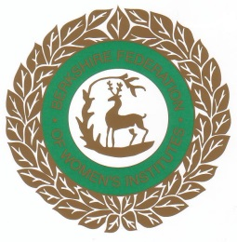

The Berkshire Federation of Women’s Institutes

The BFWI has its headquarters at WI House, Mortimer. It is run by an elected Board of Trustees supported by two part-time staff; the Federation Secretary and a Financial Assistant. Elections for the Board of Trustees are held every three years. The Board comprises of a maximum of 15 Trustees from which the Federation Officers - Chairman, Treasurer and 2 vice-chairmen are elected.

There are a number of sub-committees which organise a range of events and activities for Berkshire members.

BFWI publishes a bi-monthly newsletter Berkshire News to keep its members informed of all the events and activities in the county. This is available in both hard and electronic form and can be ordered through your WI.

The BFWI Year Book is an annual publication issued to every WI in the County. As well as details of each WI it also contains information about speakers, sub-committees, WI Groups, and lots more. Your WI Secretary will have a copy or if you would like your own copy they can be purchased from WI House.

For further information about the Federation please contact:

BFWI Office Hours:

WI House, The Street 10.00 a.m. to 2.00 p.m.
Mortimer Common (Tuesday to Thursday)
Reading
Berkshire RG7 3RD Closed Monday and Friday
Tel: 0118 933 3448
email: federationsecretary@berkshirewi.co.uk
financialassistant@berkshirewi.co.uk

Website: www.thewi.org.uk/berkshire

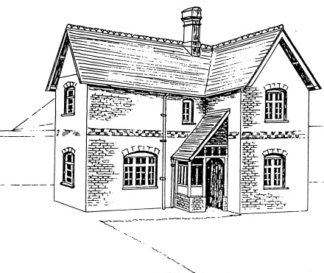

History of WI House Mortimer

1855 A Parcel of land was set aside by Edward Richard Benyon of Englefield House for the provision of a Church or Chapel, a Church Elementary School and a Clergy House.
1882 The original church, that is, the present south aisle and vestry, was completed and dedicated to St John the Evangelist.
1889 St John’s Church of England School together with a School House (now WI House) for the use of a teacher was opened.
1895 A conveyance by Richard Benyon of Englefield to the Right Reverend Father in God, William, Lord Bishop of Oxford conveyed the land and buildings as an Ecclesiastical Charity for the Church of England. There were three schedules:
- The Church
- The School and School House
- The Clergy House to the rear of the school known as St. John’s March.

1896 The enlargement of St John’s Church completed and dedicated.
1966 The land and building referred to in the third schedule, St John’s March, was conveyed from the trust to the Church Commissioners who sold it on as a private dwelling.
1989 The School House was conveyed to the Berkshire Federation of Women’s Institutes by an authority of the Charity Commission dated 13.04.1989. This is 100 years since the original opening of the school and house.

----------------------
Since the house opened in 1889 it has been occupied by a succession of teachers and later by curates. The last occupant was Miss Elizabeth Shrimpton, a parish lay worker, who retired and left the house on 25.05.1983. From that date until the sale of the house to the Berkshire Federation of Women’s Institutes it was used as a

MyWI and the Learning Hub

My WI

My Wi is the dedicated website for WI members and supporters.

You will find everything you need to get the most from WI - from essential information and advice to campaign action packs and special interest projects for you to try.

To access - go to the MyWI page online and enter the email address that you completed on the WI Membership Registration Form.

Click on "Forgot Password" and you should then receive, via email, a link to set up a password.

WI Learning Hub

The Wi Learning Hub was launched in January 2024 and it gives access to an exciting variety of courses, the majority of these are free to WI members.

Please see enclosed leaflet giving full details.

If you have any problems accessing MyWI or the Learning Hub please contact federationsecretary@berkshirewi.co.uk

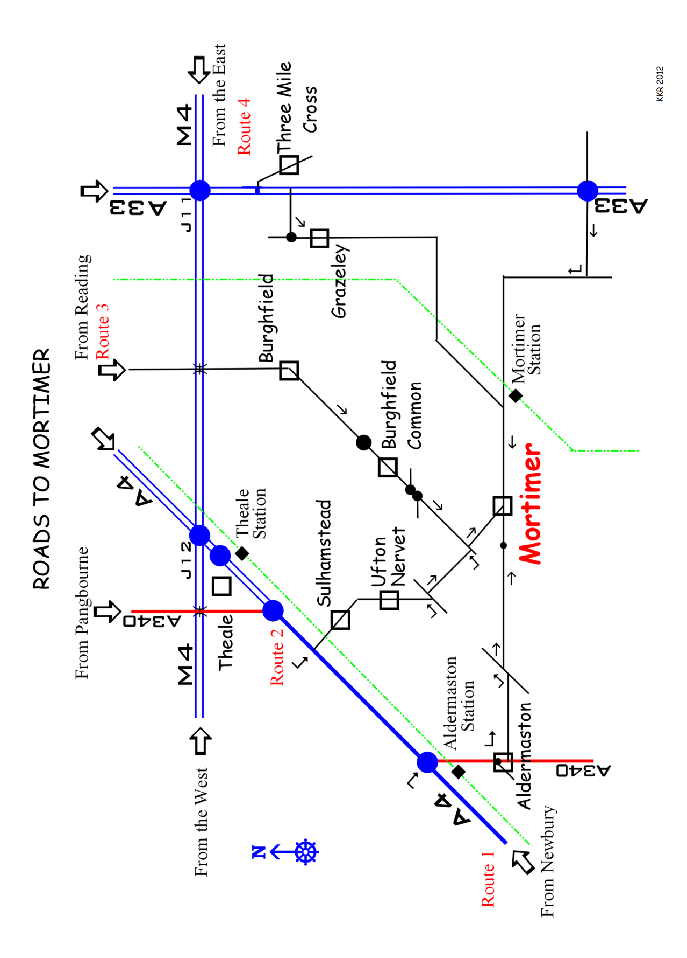
Recommended routes to Mortimer – refer to Map

Please note Mortimer West End and Stratfield Mortimer are hamlets to the West and East of Mortimer

Route 1 – From Newbury and the A4 West

Travel on the A4 towards Reading
Turn Left at the roundabout signposted A340 Aldermaston
Entering Aldermaston continue forward at mini-roundabout through village. At top of main street bear Left onto Church Road signposted Padworth, Silchester, Mortimer. Continue on Red Lane to Tjunction and then turn Left and next Right. Continue on to Mortimer.

Route 2 – From Pangbourne/M4 Junction 12/Theale

Travel on the A4 towards Newbury
Turn Left at the ‘Spring Inn’ signposted – Sulhamstead, Police Training College. Continue on this road onto Sulhampstead Hill, Church Lane and through Ufton Nervet. Turn Left at Tjunction and then next on the Right into Victoria Road. Turn Left and then Right at the Tjunction and forward to Mortimer.

Route 3 – From Reading A4

Travel out of Reading on A4 towards the M4 Junction 12
Turn Left at the traffic lights signposted Burghfield.
Remain on this road through Burghfield, Burghfield Common and continue forward at two mini-roundabouts signposted Mortimer.
Continue on this road into Mortimer.

Route 4 – From M4 Junction 11/ Reading A33
Travel from the M4 Junction 11 on the A33 towards Basingstoke.
After the first set of traffic lights filter right at next traffic light junction (approximately 250 metres) onto Mereoak Lane, then turning left to Burghfield and Mortimer. Continue on this road through Grazeley and onto Mortimer.

